

SESSION 2019/2020 SEMESTER 1

ASSIGNMENT 2

**NAME**:

1) LIM BAO JING (A17CS0076)

2) LOW CHIA JING (A17CS0083)

3)TAN SEE JOU (A17CS0218)

**LECTURER NAME:** DR. MD. SAH BIN HJ. SALAM

**SUBJECT NAME:** FUNDAMENTAL OF IMAGE PROCESSING

**SUBJECT CODE:** SCSV 3213

**SECTION:** 01

Contents

**A.** **The codes and documentation** 3

**Load Image** 3

**Darken Image** 4

**Blur Image** 5

**Sharpen Image** 6

**Brighten Image** 7

**Save Edited Image** 8

**B. Flow Chart** 9

**Procedure in solving the task** 10

Create Blank GUI 10

Create a Panel 10

Create axes 11

Create push buttons 12

Create LoadImage_Callback function 12

Create DarkenImage_Callback function 12

Create BlurImage_Callback function 12

Create SharpenImage_Callback function 13

Create BrightenImage_Callback function 13

Create SaveImage_Callback function 13

Arrange GUI elements 13

Add user guidelines 14

**C. Output** 15

**The final GUI** 15

**The User Process Chart - how they use this application** 15

**Load Image** 16

**Darken Image** 17

Save darken image 18

**Blur Image** 19

Save Blur Image 19

**Brighten Image** 21

Save Brighten Image 21

**Sharpen Image** 23

Save Sharpen Image 23

**Sample Output by mixing all of the Operation** 25

# **The Codes and Documentation**

## **Load Image**

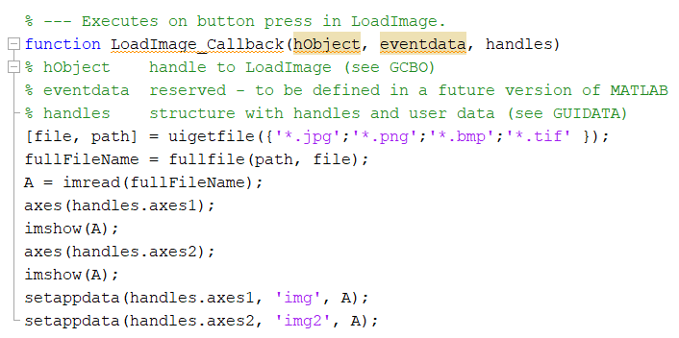

*Figure 1: Load image*

This function enables users to load image from their computer. By using ***uigetfile(‘*. ’)***, a modal dialog box will list the files with the specific extension available in the current folder. User is able to enter or select the file that desire, and if the file is valid, ***uigetfile()*** will return the path and the file name when the user click open. This dialog box aims to prevent the user from interaction with other Matlab windows. ***Fullfile()*** function is used to build a full filename from the directories and filename specified. After that, ***imread()*** function applied to read the image from graphics file. Before showing the image on first axes, ***axes(handles.axes1)*** is mention so that the current axes is set to axes1, so that any operation carry on will only apply to axes 1. After ***A*** display it with ***imshow(A)*** to the axes1, ***A*** store the variable ***A*** to the ***handles.axes1*** and with name ‘img’, which is ***setappdata(handles.axes1, ‘img’, A)*** and ***setappdata(handles.axes2, ‘img’, A)***. Then, same goes to axes2 which is for the edited image.

## **Darken Image**

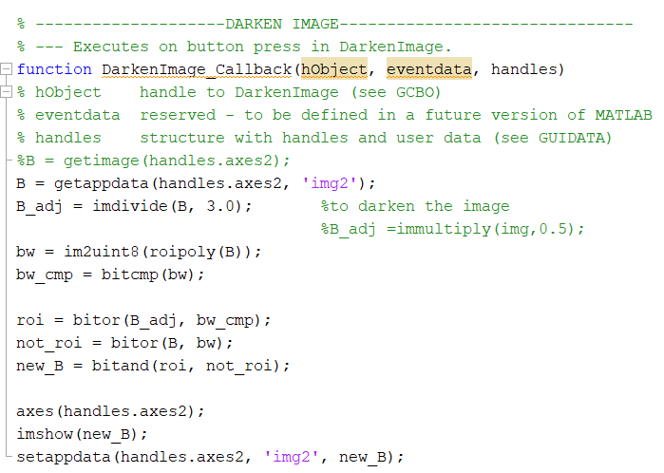

*Figure 2: Darken image*

This function enables users to choose the area of the image to be darkened by connecting the points to form a region. Firstly, before processing the image, we have to obtain the data of the image. There are 2 approaches we used to obtain the image data. The first one is ***getimage()*** which returns the first image data contained in the graphics object h. In our case, the h is the axes2. The second approach is the ***getappdata()*** which is used to retrieve data stored using the setappdata() which we have used before. After we obtained the image data, we can start to process the image. To darken the image, we also have 2 approaches. The first one is using the ***imdivide()*** which can be used to divide the value of the element in the image with a certain value. In our case, we divide the value of all the elements of the image with 3. So, all the value of the elements will become smaller which means the image will become darker. The second one is using the ***immultiply()*** which can be used to multiply the value of the element in the image with a certain value. In our case, we multiply the value of all the elements of the image with 0.5. When the value that is going to be multiplied is lower than 1, it will cause the values multiplied with it become smaller which causes the image to become darker. After that, to enable users to choose the region to be processed. We have to use the ***roipoly()*** which creates an interactive polygon tool that returns the mask as the binary image which sets pixels inside the ROI (Region Of Interest) to 1 and pixels outside the ROI to 0. After that, we converted the binary image to uint8 using ***im2uint8()*** and complement the mask with ***bitcmp()***. After that, use logic operator ***bitor()*** on darker image***(B_adj)*** and compliment polygon selected, ***bw_cmp***. Same goes to image(***B***) and ***bw***. Then, logic operator ***bitand()*** is applied to ***roi*** and ***not_roi***. Lastly, show the image on axes 2 and store it using ***setappdata()***.

## **Blur Image**

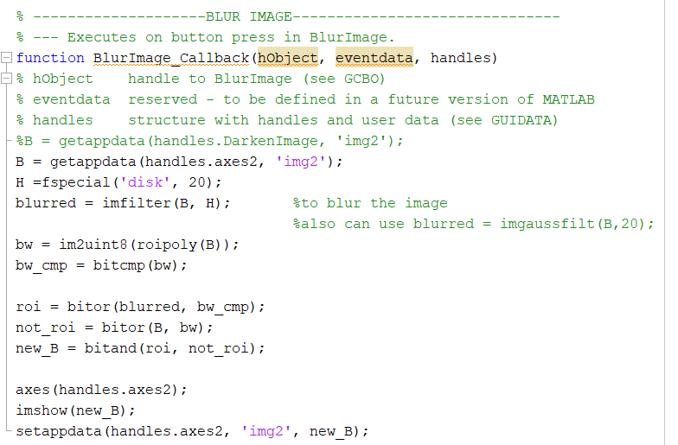

*Figure 3: Blur image*

For the obtaining of image data, enabling users to choose ROI and storing the new data for the processed image, the codes are exactly the same as the others. The only thing different is the operation to process the image data. To blur the image, we also have 2 approaches. First one is using ***fspecial()*** which is used to create predefined 2-D filter. In our case, we used ***fspecial(‘disk’, radius)***, and set the radius to 20. Then, applied ***imfilter()*** to the original image with the blur operation. The other method that enable the blurring effect is applied ***imgaussfilt()***. This function is used to filter the image with a 2D Gaussian smoothing kernel with standard deviation specified with sigma. After that, the following operations is the same as the darken image function above.

## **Sharpen Image**

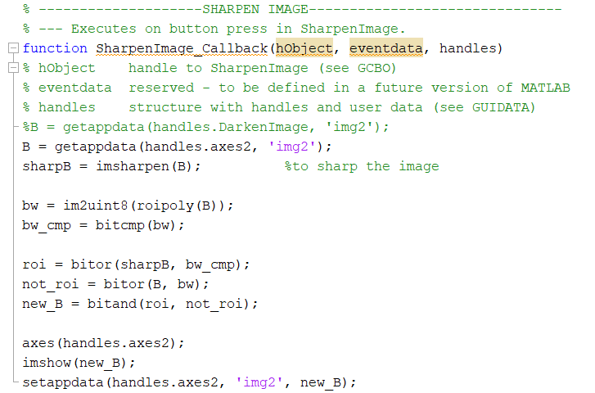

*Figure 4: Sharpen image*

This sharpen image function enables user to choose the parts of the image to be sharpened. ***Imsharpen()*** function had been applied to increase the contrast along the edges of the color meet by using ***unsharp*** masking method. It can applied to grayscale or true color image. Unsharp masking is subtracting a blurred version of the image from itself. After that, the following operations carried on to the image is the same as the above function.

## **Brighten Image**

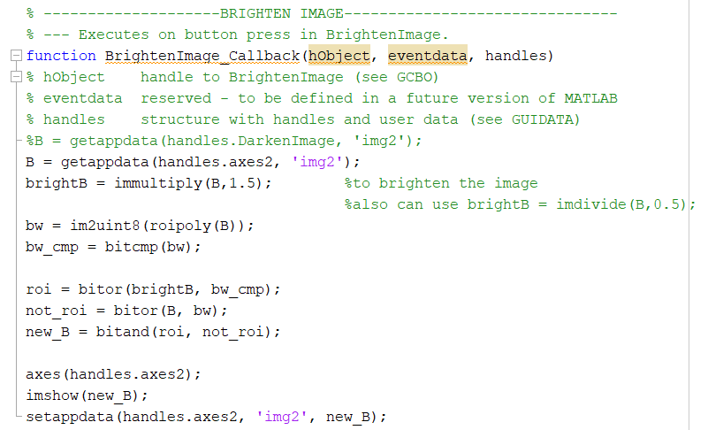

*Figure 5: Brighten image*

For the obtaining of image data, enabling users to choose ROI and storing the new data for the processed image, the codes are exactly the same as the others. The only thing different is the operation to process the image data. To brighten the image, we also have 2 approaches. The first one is using the ***immultiply()*** which can be used to multiply the value of the element in the image with a certain value. In our case, we multiply the value of all the elements of the image with 1.5. So, all the value of the elements will become bigger which means the image will become brighter. The second one is using the ***imdivide()*** which can be used to divide the value of the element in the image with a certain value. In our case, we divide the value of all the elements of the image with 0.5. When the value that is going to be divided is lower than 1, it will cause the values divided with it become bigger which causes the image to become brighter.

## **Save Edited Image**

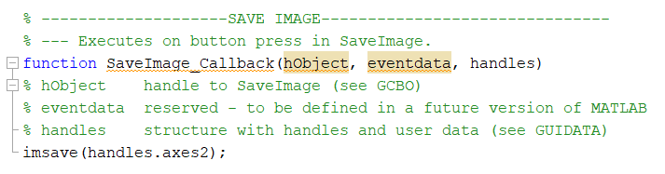

*Figure 6: Save edited image*

***imsave()*** can be used to create a Save image tool. The Save Image tool displays an interactive file chooser dialog box in which the user can specify a path and filename. When the user clicks Save, the Save Image tool writes the target image to a file using the image file format user selected in the Files of Type menu. In our case, only the image in axes2 will be saved since we specified it.

# **B. Flow Chart**

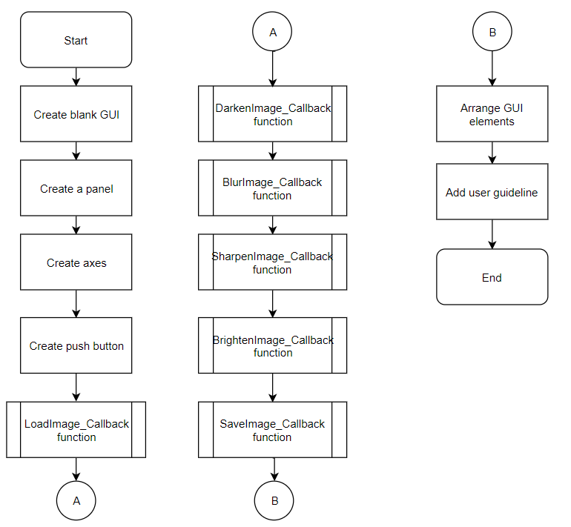

*Figure 7: Flowchart of the process*

## **Procedure in solving the task**

### Create Blank GUI

First, we use the comment ‘guide’ and create a blank GUI.

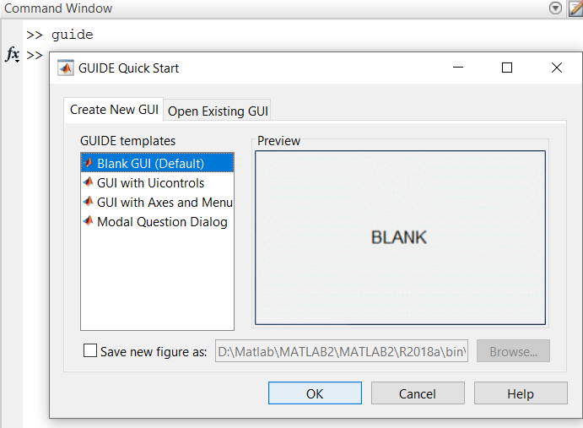

*Figure 8: Command window for creating blank GUI*

### Create a Panel

We drag a panel which is suitable for the size of the GUI. The panel then will become the background which contains all of the GUI elements.

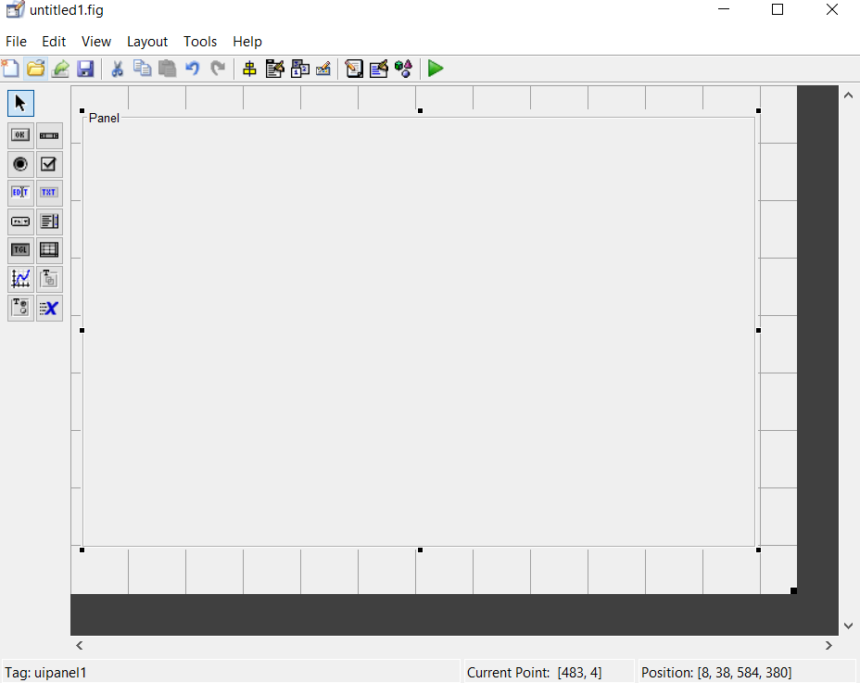

*Figure 9: Creating Panel*

### Create axes

We create two axes and these two axes will then become the container for image loading.

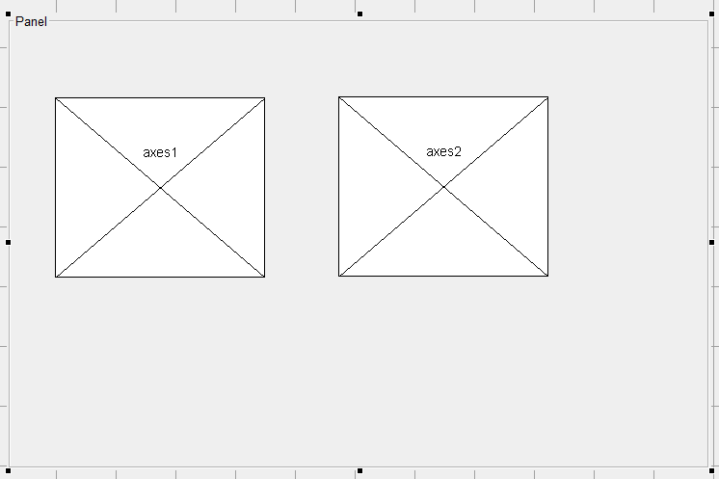

*Figure 10: Creating axes*

### Create push buttons

We create several push buttons, change their name which match their function.

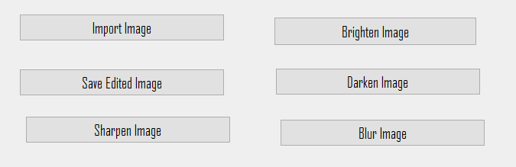

*Figure 11: Creating push buttons*

### Create LoadImage_Callback function

We create a LoadImage_Callback function for the ‘Import Image’ button which can let user to load an image into both axes from their computer (refer Figure 1).

### Create DarkenImage_Callback function

We create DarkenImage_Callback function for the ‘Darken Image’ button which can let user to darken the selected region (refer Figure 2).

### Create BlurImage_Callback function

We create BlurImage_Callback function for the ‘Blur Image’ button which can let user to blur the selected region (refer Figure 3).

### Create SharpenImage_Callback function

We create SharpenImage_Callback function for the ‘Sharpen Image’ button which can let user to sharpen the selected region (refer Figure 4).

### Create BrightenImage_Callback function

We create BrightenImage_Callback function for the ‘Brighten Image’ button which can let user to brighten the selected region (refer Figure 5).

### Create SaveImage_Callback function

We create SaveImage_Callback function for the ‘Brighten Image’ button which can let user to save the edited image in their computer (refer Figure 6).

### Arrange GUI elements

We arrange all the GUI elements such as grouping all of the push button in a container, assigning title to both the image and also editing the panel name. This can make a better GUI which is more clean and easy to use.

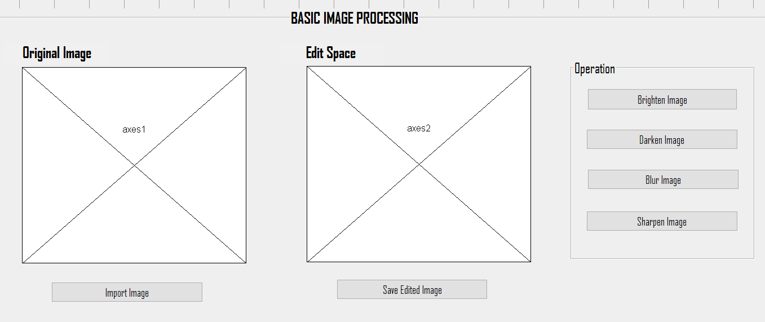

*Figure 12: Arranged GUI elements*

### Add user guidelines

To make the GUI more user-friendly, we added step-by-step user guidelines to help user to understand the procedure of using this application.

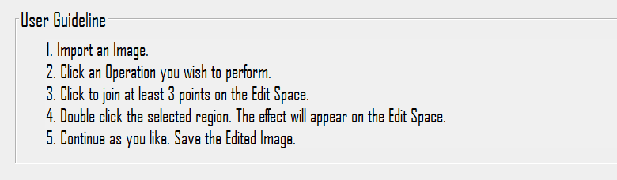

*Figure 13: User guidelines in the GUI*

# **C. Output**

## **The final GUI**

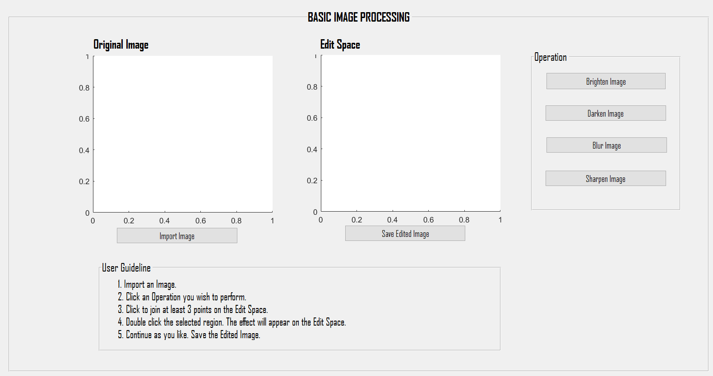

*Figure 14: The final GUI*

## **The User Process Chart - how they use this application**

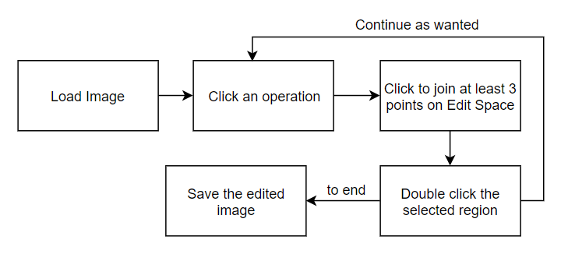

*Figure 15: The user process chart*

## **Load Image**



*Figure 16: User is able to browse any image from their computer once they clicked ‘Import Image’ button*

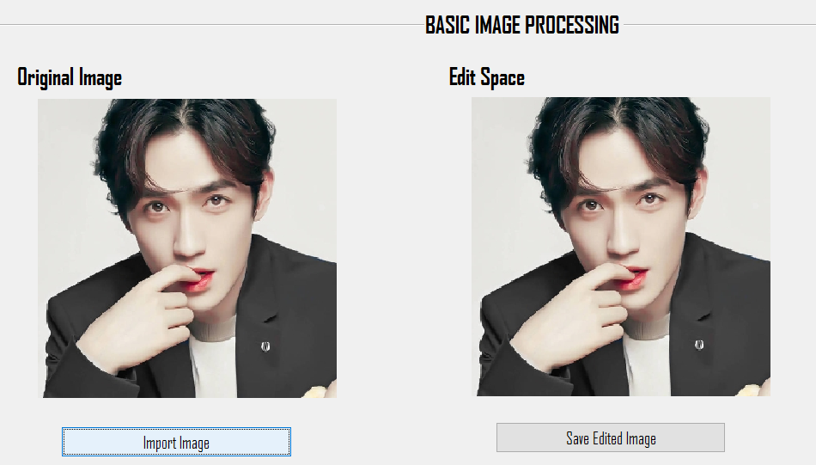

*Figure 17: The selected image will be placed in both axes*

**Choose part in the Edit Space**

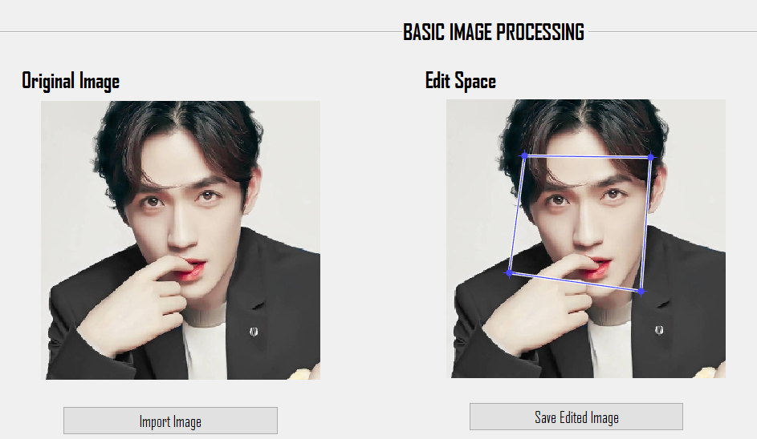

*Figure 18: The operation enables users to choose the area of the image to be edited by connecting the points to form a region.*

## **Darken Image**

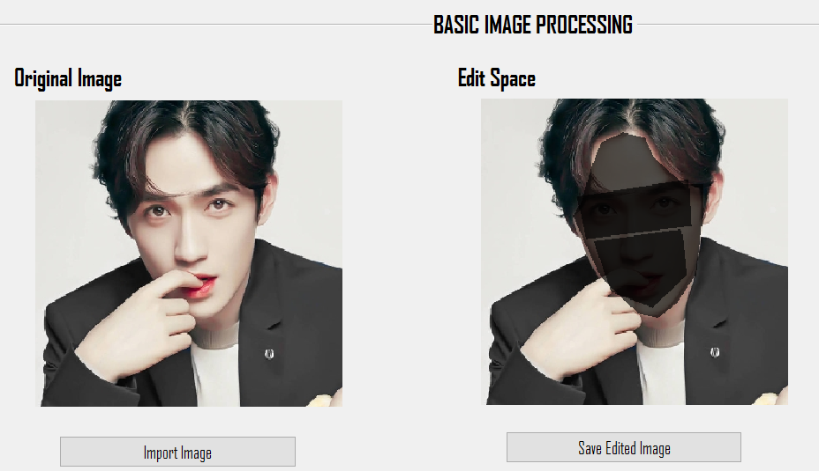

*Figure 19: The ‘Darken Image’ effect - user can apply more than 1 times*

### Save darken image

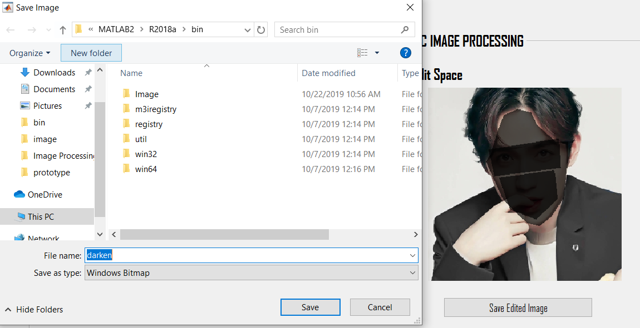

*Figure 20: User can save the edited image in computer when they pressed ‘Save Edited Image’ button*

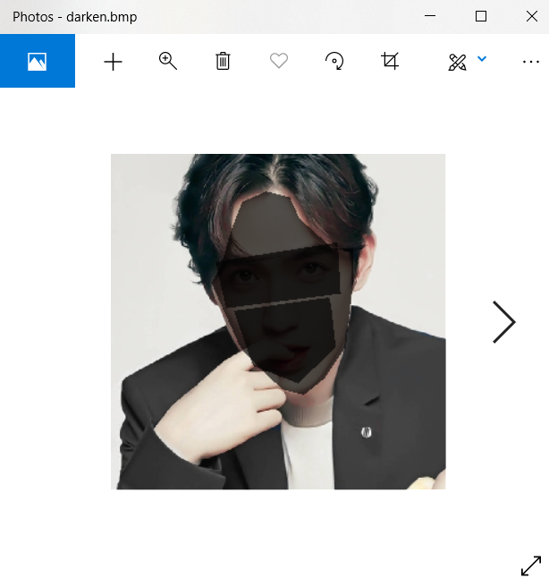

*Figure 21: The saved image*

## **Blur Image**

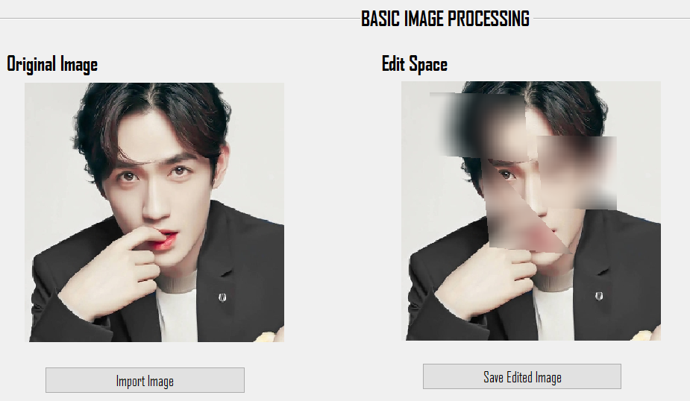

*Figure 22: The ‘Blur Image’ effect*

### Save Blur Image

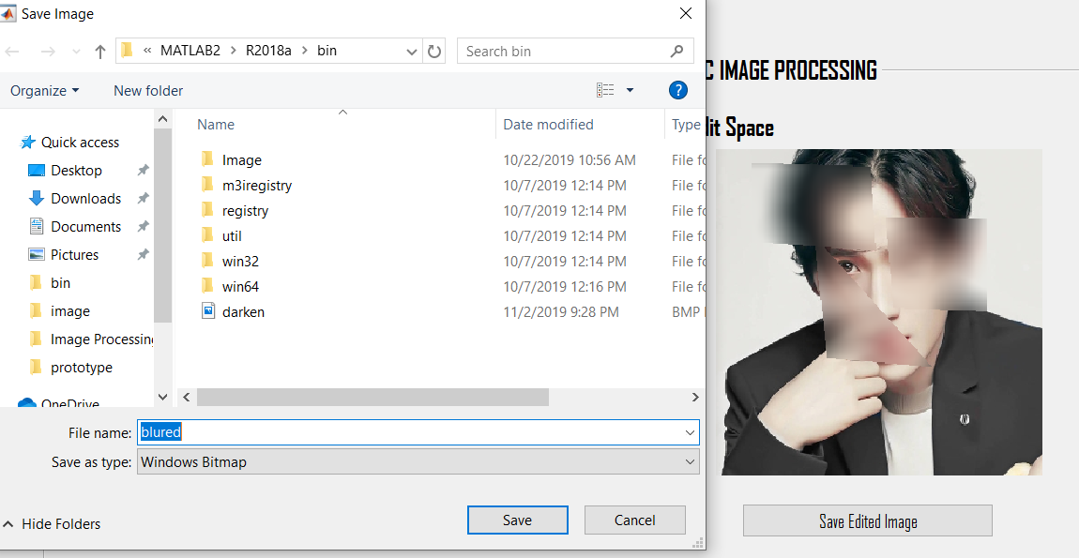

*Figure 23: User can save the edited image*

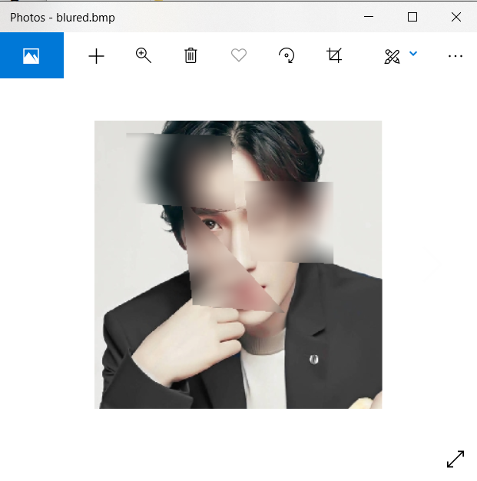

*Figure 24: The saved image*

## **Brighten Image**

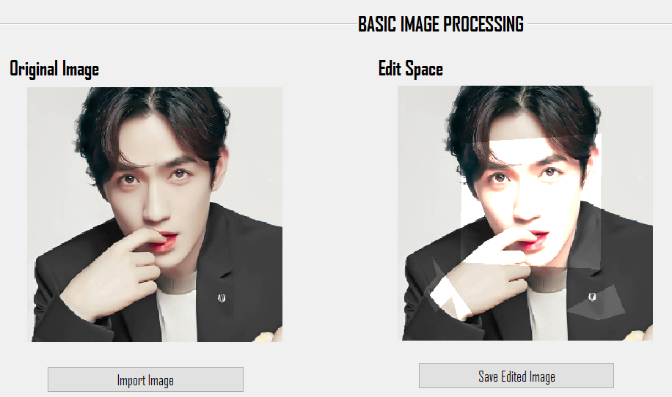

*Figure 25: The ‘Brighten Image’ effect*

### Save Brighten Image

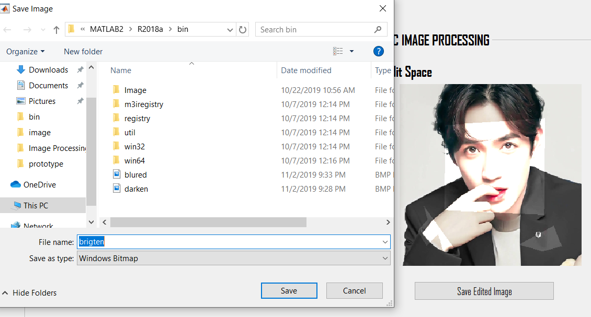

*Figure 26: User can save the edited image in computer*

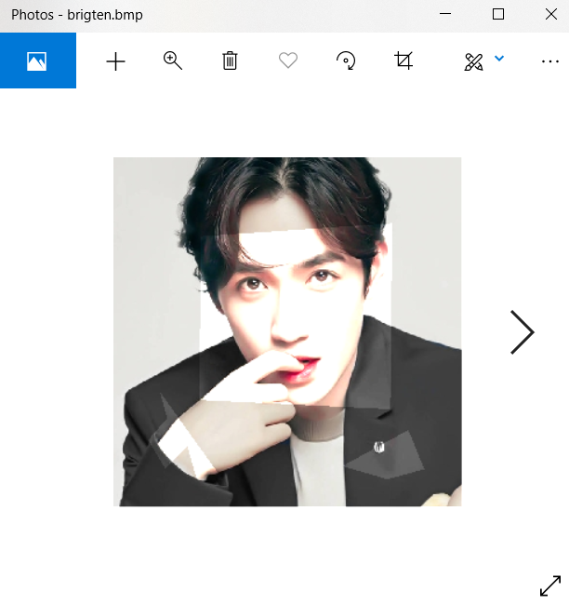

*Figure 27: The saved image*

## **Sharpen Image**

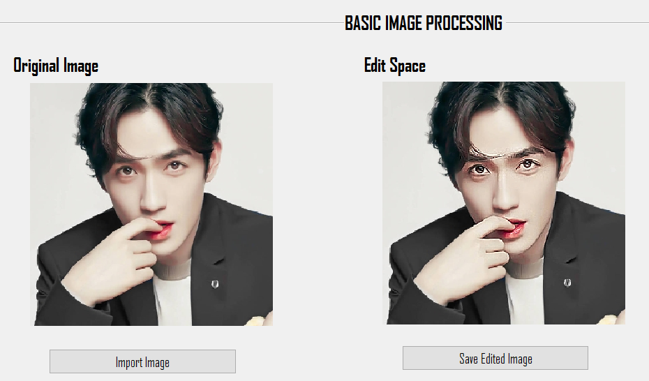

*Figure 28: The ‘Sharpen Image’ effect*

### Save Sharpen Image

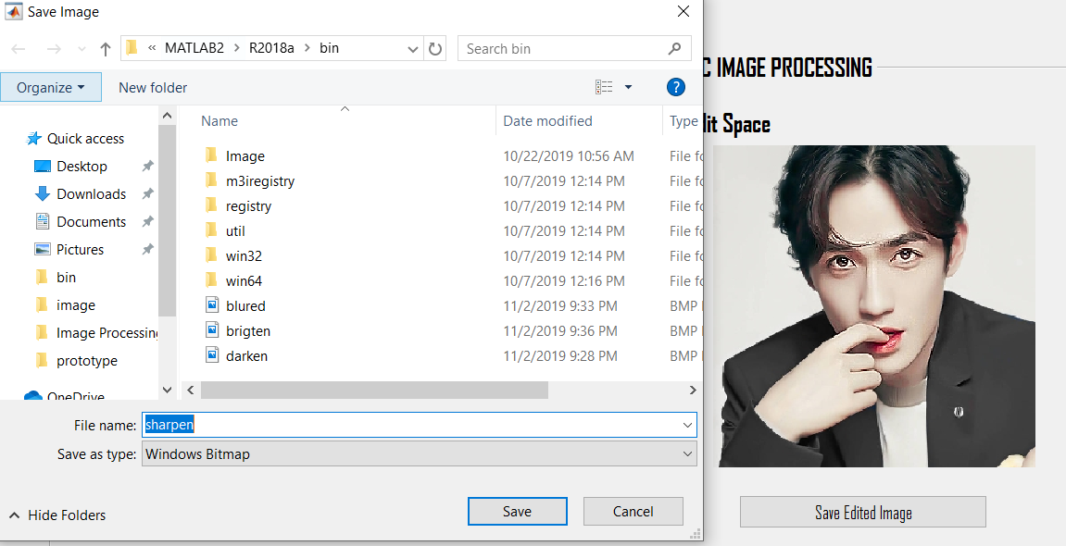

*Figure 29: User can save the edited image in computer*

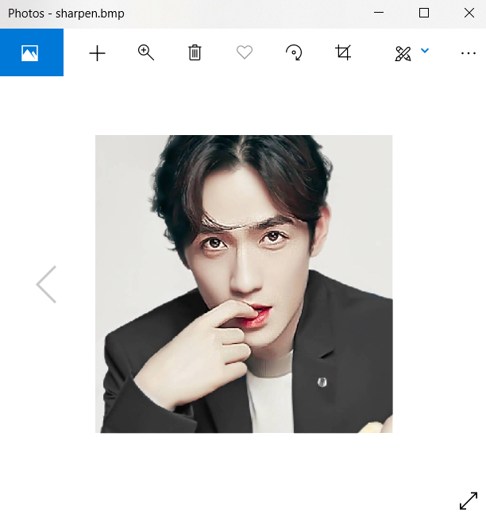

*Figure 30: The saved image*

## **Sample Output by mixing all of the Operation**

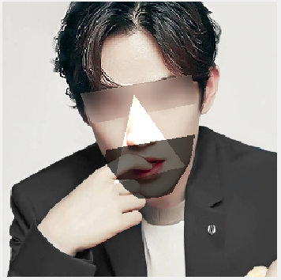

*Figure 31: The sample output -1*

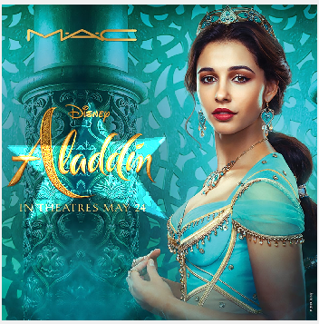

*Figure 31: The sample output -2*